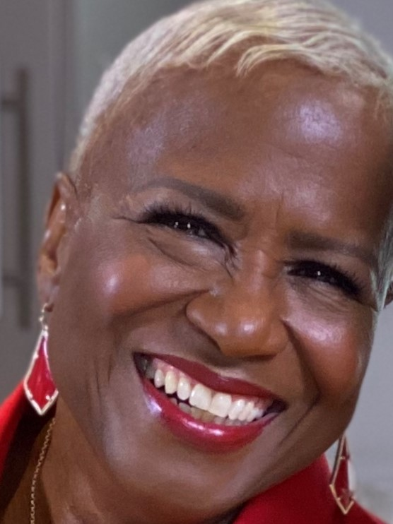 |  | MONICA’S FIVE TAKEAWAYS ON HOW TO “GET” THE mEDIA
Monica Pearson  Monica.Pearson@cmg.com |  | Form relationships with media before you need them. Have a list of media contacts, including managers at media outlets.  Be involved in the community and share what you are doing in your inhouse communications, as well as with targeted media.  Be social, have a consistent and regular presence on social media.  When there is a crisis, have a crisis manager or hire one to work with media,  Download a free copy of How Journalists and the Public Shape our Democracy, from GeorgiaHumanities.org to understand the role of media and your role in it.

